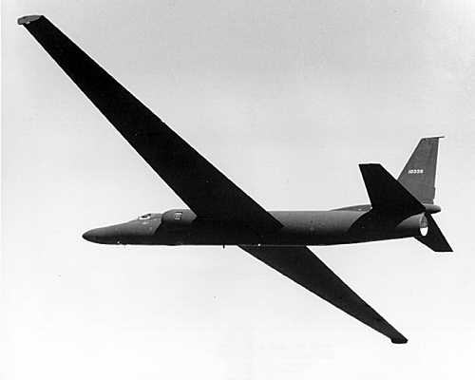
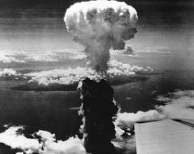
The Cold War
Chronology
- Yalta – February 1945
- Potsdam Conference – July 1945
- Fulton Speech – February 1946
- Truman Doctrine – March 1947
- Marshall Plan – June 1947
- Cominform – October 1947
- Czechoslovakia – Marshall Plan accepted – February 1948
- Berlin Blockade – 1948 – May 1949 (11 months long)
- Korean War – 1950-53
- Stalin dies, Khrushchev succeeds – 1953
- Warsaw Pact & “Peaceful coexistence” – 1955
- Hungarian Uprising – 1956
- Sputnik satellite launched -1957
- Fidel Castro comes to power - 1959
- U2 Crisis – May 1960
- Berlin Wall built – 1961
- Cuban Missile Crisis - 1962

Yalta
Churchill, Roosevelt and Stalin
Decided to:
- Bring Nazi war criminals to justice.
- Split Germany and Berlin up into 4 parts.
- Set up a commission to look into reparations.
- For Russia to join UN.
- Allow liberated Eastern Europe to have free, democratic elections.
- Shift Poland westwards for Russia to build up defences.
- Russia would help GB and USA in Japan.
But:
- Stalin’s idea of a “free election” was a communist view.
- He placed communist leaders loyal to the USSR in most Eastern European countries and they killed the non-communist opposition.
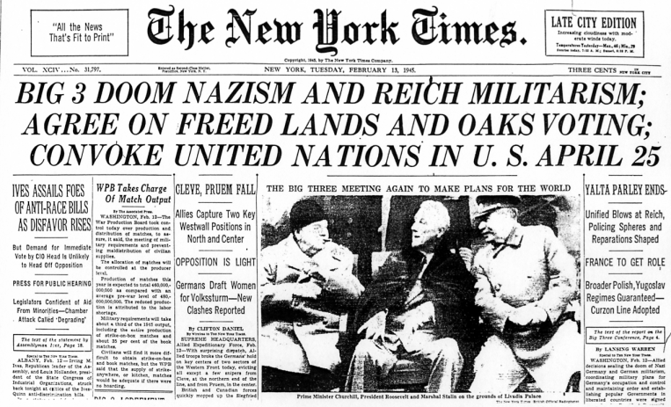
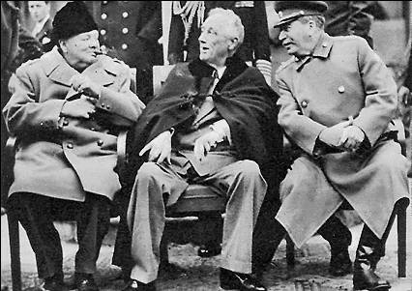
- The USA developed the atomic bomb but didn’t tell Stalin.

Potsdam
Atlee, Truman and Stalin
Decided on protocols to:
- Bring Nazi war criminals to trial.
- Divide Berlin and Germany between France, USA and GB.
- Free, unfettered elections in Poland.
- Let USSR take reparations from its zone and 10% of industrial equipment from other zones in Germany.
But they disagreed about:
- Size of reparations to be paid to USSR.
- Russia’s influence over Eastern Europe.
- The details about how to divide Germany.
This was because:
- The new President, Truman, took a more hard-line approach to the USSR.
- “Tired of babying the soviets.”
- Atlee new and inexperienced.
- Didn’t get on very well.

Fulton Speech (1946)
- Churchill gave speech in Fulton, Missouri.
- “...an iron curtain has fallen across the continent...”
- Stalin saw it as an unofficial declaration of cold war.
- “Mr. Churchill has called for a war on the USSR.”

The Truman Doctrine &The Marshall Plan
Truman Doctrine (1947) promised to provide:
- Advice
- Financial aid
- Arms
To any country in danger of falling to communism.
Policy of Containment!
Background:
- Greece and Czechoslovakia only non-Communist countries in E.Europe.
- British soldiers supporting royalists in Greece against communists.
- Couldn’t afford it anymore.
- Told USA.
- Gave money to support British soldiers.
General Marshall:
- Said every country in Europe was so poor they were in danger of communism.
- Said USA should give $17 billion.
- Congress refused at first – citizens not happy about money going to Europe.
- Czechoslovakia became communist.
- Congress approved Marshall Aid – got Europe’s economy going again.
- America reduced threat of communism and had more people to trade with.
Cominform (1947):
- Stalin hated Marshall Aid.
- Didn’t allow communist countries to accept money.
- Made them all join Cominform.
- Gave him more control.
The Berlin Blockade
June 1948 – May 1949
Why?
- Britain and USA merged zones.
- Introduced new currency against Stalin’s wishes.
- Pumped lots of money into West Berlin.
- Thought they were trying to strengthen Germany so they could oust him.
So...
- Stalin decides to blockade west Berlin.
- Hopes it will be defeated and become part of Communist East Germany.
Three options for west:
- Invade Berlin. Would result in war. (But not M.A.D – Russia developed A-Bomb after this.)
- Do nothing. Would make them seem weak.
- Use air corridors. Could be dangerous.
- They go for option 3
- Provide 1.5 million tonnes of supplies for West Germany.
- Blockade becomes ineffective.
- So Stalin lifts it.

Results:
- USA got a lot of good propaganda out of it.
- 2 New countries. West Germany and East Germany.
- West sped up plans to improve Germany economy etc.
- NATO was formed.
- The Warsaw Pact followed.
- Arms Race.

Korean War
What happened:
- North Korea – communist, backed by USSR.
- South Korea – not communist – Backed by USA.
- Divided along 38th parallel.
- Both wanted to conquer each other.
- June 1950 – surprise attack by N.Korea on S.Korea.
- Unprepared – only Pusan not conquered by August.
- UN security council asked for aid to be sent.
- USSR boycotting it so couldn’t veto.
- Troops mostly American led by Macarthur.
- Army landed 200 miles behind enemy lines.
- Launched attack on N.Korea at Pusan.
- N.Korea retreated.
- Macarthur invaded N.Korea going as far as Chinese border.
- Alarmed Chinese sent “people’s volunteers” (i.e. troops in disguise) to push them back.
- Chinese recaptured N.Korea and went to S.Korea.
- More troops came, pushed the Chinese back to 38th parallel.
- Truman told Macarthur to stop.
- He didn’t then was sacked.
- Eisenhower became President 1953 – ordered Chinese to stop fighting or they’d use A-Bomb.
- Stopped. Truce was signed.
- An estimated 10 million killed.

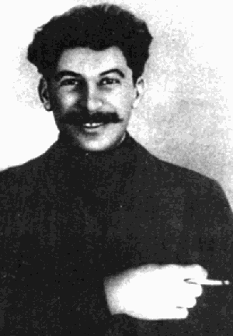
1953 -Stalin dies...

Succeeded by Nikita Khrushchev
USA hoped:
- There would be a thaw in the cold war.
- He would loosen his grip on Eastern Europe.
Because:
- Of his speech about “peaceful coexistence”.
- His criticism of Stalin and destalinisation.
- He returns military bases Russia took in Finland.
But:
- He just wants USSR to be more efficient.
- Only wanted to lessen hold on economy so they could get consumer goods like USA.
- Wanted less centralisation.
- But still wanted to expand communist empire.

Hungarian Uprising
1956
Why?
- Hated Russian communism.
- Thought Khrushchev might be a bit more lenient than Stalin.
- Thought the West would support them.
- Were very poor and were suffering yet lots of their produce went to USSR.
- Angry about Catholic Church being banned (communism = secular).
What happened?
- Lots of people rioted in the streets.
- Imre Nagy became new PM.
- He asked Khrushchev to remove Russian troops.
- He complied.
- Pushed through a series of reforms Oct. 29th – Nov. 3rd.
- Introduced freedom of religion, press, speech and democracy.
- Then he asked to withdraw from Warsaw Pact.
- Khrushchev hated this.
- 4th Nov. sent troops into Hungary, destroying the Hungarian army.
- 4000 Hungarians killed, 200,000 fled to Austria.
- Nagy was executed, USSR loyal Kadar replaced him.
- West was horrified but did nothing
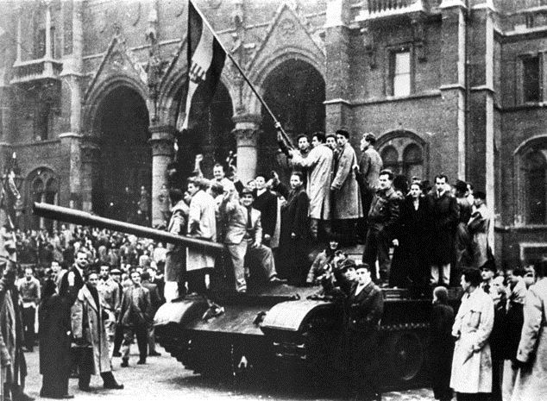

Why didn’t the West intervene:
- Didn’t think Hungary was worth a war.
- Had no reason to do so under Truman Doctrine (already communist).
- Distracted by Suez Crisis.
Why did Khrushchev do it?
- Wanted protective “buffer states”.
- Didn’t like decision to leave Warsaw Pact.
- Knew West wouldn’t intervene.
- Under pressure from hard-liners.
The U2 Crisis
May 1960
Background:
- Tension between USA and USSR = high.
- Russia had launched Sputnik satellite in 1957 – worried USA.
- 1959 – communist Fidel Castro took power in Cuba.
- Happened days before summit to discuss nuclear weapons and Berlin.
What happened?
- May Day – USSR shot down U2 plane flying over Russia.
- Told USA who said it was a weather plane which got lost.
- Then revealed video pilot had taken proving USA was spying.
Results:
- USA caught in a lie.
- USSR uses in propaganda.
- Khrushchev demands an apology from Eisenhower and a promise to cancel spy-flights or he wouldn’t participate in summit.
- Eisenhower agrees to cancel spy-flights but refuses to apologise.
- Khrushchev leaves and summit falls apart.
- Americans angry at Eisenhower – elect “tougher” John F. Kennedy.

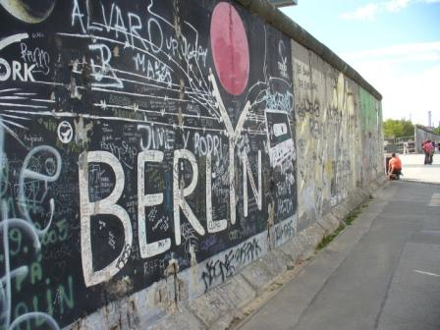
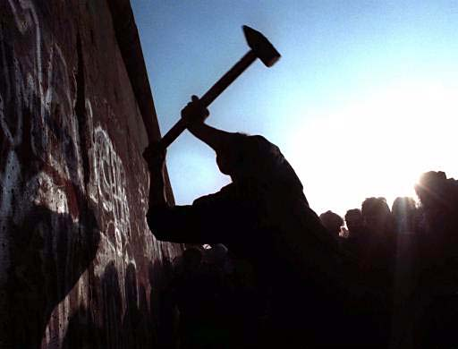
The Berlin Wall
Built 1961
Why?
- USA pumped lots of money into West German and West Berlin.
- Made it a showcase for capitalism.
- Conditions in East Germany were bad.
- Lots of skilled workers and others were leaving East Germany for West Germany.
- 3 million had left by 1961.
- Embarrassing for USSR.
- USSR claimed the USA were using West Berlin for spying and sabotage.
So...
- Khrushchev demanded that JFK give West Berlin to him.
- Refused, so Khrushchev built wall.
- Many died trying to cross it because of machine guns etc.
Results:
- Annoyed the West but not worth war.
- Became a symbol of the tyranny of communism.
- USA used in propaganda.
- Tensions increased, West became more anti-communist.

Cuban Missile Crisis
Background
- All the tension between the USA and the USSR was coming to a head.
- Fidel Castro (communist) took over Cuba which scared USA.
- Stops trading with Cuba, so Cuba must turn to USSR who made a trade agreement with them.
- In retaliation Cuba nationalises lots of American owned companies.
- CIA trains Cuban exiles to try and topple Castro in Bay of Pigs Operation (fails).
- Cuba asks USSR for weapons to protect them against USA and get them.
What happened?
- 14th October – USA discovers missile bases in Cuba.
- 22nd October – JFK announced naval blockade of Cuba.
- 25th October – Russian ships carrying missiles forced to turn back.
- 26th October – JFK began planning military action against Cuba then received telegram from Khrushchev saying he would remove the bases if USA promised not to attack Cuba and removed the naval blockade.
- 27th October – Before JFK could reply, Khrushchev sent a second telegram asking him to remove missile bases in Russia in return for him removing those in Cuba. JFK wrote back agreeing to the terms of the first letter, not the second and ignored it when a U2 plane was shot over Cuba.
- 28th October – Khrushchev agreed and the crisis ended.
Results:
- Khrushchev humiliated – China breaks away from USSR.
- JFK praised as hero for beating USSR and preventing war.
- Aware of how close they came to war so were more cautious in the future.
- Set up a “hotline” between Moscow and Washington so they could talk if there was another crisis.
- 1963 – Nuclear Test Ban Treaty.
- Cold war began to thaw.

